Notes on Mendota QA/QC for Catchment metabolism project
Notes below by Jen Klug on 2/16/16 and 6/2/16
Using files generated by Jake (see below)
Mendota_wtr contained wind data so downloaded hourly water temp data from NTL-LTER website.
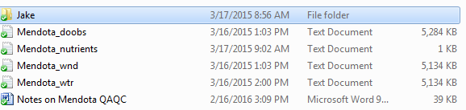

METADATA – no metadata in metadata file as of 2/16/16
Mendota DO sensor depth = 0.5 m (according to metadata on LTER website)
atmPres <- #average atmospheric pressure at local elevation, mmHg
windHeight <- 2 m
timeStep <- 1 time step in DO file is 1 minute but will need to be downsampled to hourly to match light
lat<- 43.0995 #latitude of lake Mendota

DO file
Missing rows for 7/30/2013 – added rows w/ NA for each minute as per Data Request Form
No obvious outliers or abnormalities
Wind file
No values below 0
Lots of brief periods (<10 min) periods of missing data (2987 total observations of NA)
Missing rows for 7/30/2013 – added rows w/ NA for each minute as per Data Request Form
No obvious outliers or abnormalities
Temperature profile data file
Plotted each depth by time.
Removed early season dates to match DO data.
No obvious outliers or abnormalities

PAR data
Corinna said that there is no light sensor on the Mendota buoy. She suggested the National Solar Radiation database which has Madison data but this database only has data up to 2010. Luke suggested ISIS data but I had trouble finding appropriate metadata. Hillary Dugan suggested using the NLDAS2 met data. NLDAS2 has Short Wave radiation which can be converted to PAR in lakeMetabolizer.
Mendota light data in the QA/QC file is shortwave radiation.
Plotted data
No obvious outliers or abnormalities

